**AI-Driven Personalized Study Plan Generator**

Snehith Reddy Banala(S00443307), Chaitanya Bandaru(S00424747)

**Project Description**

The AI-driven personalized study plan generator is a web-based application that creates tailored study plans for users based on their subject, level, duration, and learning goals. Utilizing artificial intelligence, the system generates comprehensive study plans that include daily tasks, concept-wise data, and milestones. Users can view, manage, and interact with their generated study plans through an intuitive interface.

**Project Scope**

**Entities and Functions**

1. User
   * Login (via Firebase OAuth 2.0)
   * Manage profile
   * Request study plan
   * View study plans
   * Delete study plans
2. Study Plan
   * Generate plan (AI-driven)
   * Store plan
   * Retrieve plan
   * Delete plan
   * Display plan
3. AI Service
   * Process user input
   * Generate personalized study plan
4. Authentication Service (Firebase OAuth 2.0)
   * Handle user authentication

**Initial Database Design (MySQL)**

1. Study Plans Table

CREATE TABLE study_plans (

    id INT AUTO_INCREMENT PRIMARY KEY,

    subject VARCHAR(255) NOT NULL,

    level VARCHAR(255) NOT NULL,

    duration VARCHAR(255) NOT NULL,

    goals TEXT NOT NULL

    plan TEXT NOT NULL,

    created_at DATETIME NOT NULL

);

CREATE TABLE users (

    id INT AUTO_INCREMENT PRIMARY KEY,

    uid VARCHAR(255) NOT NULL UNIQUE,  *--* Firebase UID

    display_name VARCHAR(255),

    email VARCHAR(255) NOT NULL UNIQUE,

    photo_url TEXT,

    created_at TIMESTAMP DEFAULT CURRENT_TIMESTAMP,

    last_login TIMESTAMP DEFAULT CURRENT_TIMESTAMP ON UPDATE CURRENT_TIMESTAMP

);

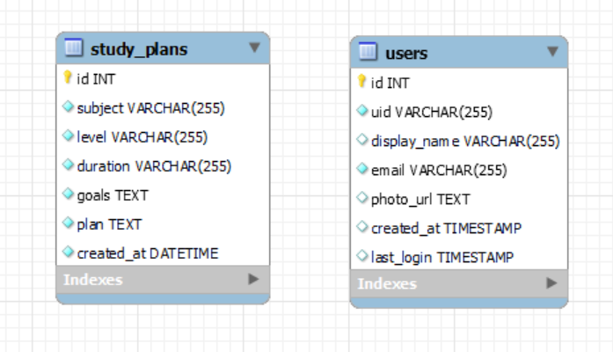

**Frameworks and Technologies**

1. Backend:
   * PHP (Core language)
   * MySQL (Database)
2. Frontend:
   * HTML5
   * CSS3
   * Bootstrap
   * JavaScript
3. AI Integration:
   * Hugging Face's Inference API (for AI-driven plan generation)
4. Authentication:
   * Firebase Authentication (OAuth 2.0)

This project combines web development with AI integration, providing a unique and valuable tool for students and learners to optimize their study strategies.